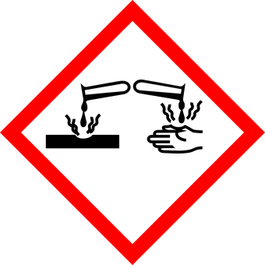
Acid Reactions
A science technician has found three old bottles of chemicals that have lost their labels. They think that one contains calcium metal, another contains calcium oxide and the third contains calcium hydroxide.
Describe how the technician could use hydrochloric acid to determine which bottle contains each substance.
You should include word equations or balanced symbol equations where appropriate.

_______________________________________________________________________________________
_______________________________________________________________________________________
_______________________________________________________________________________________
_______________________________________________________________________________________
_______________________________________________________________________________________
_______________________________________________________________________________________
_______________________________________________________________________________________
_______________________________________________________________________________________
_______________________________________________________________________________________
_______________________________________________________________________________________
_______________________________________________________________________________________
_______________________________________________________________________________________
_______________________________________________________________________________________
_______________________________________________________________________________________
Teacher Guidance

Purpose of this activity
This task presents an opportunity for pupils to
- write an extended response, demonstrating the depth of their understanding of the current topic.
- apply their knowledge in an unfamiliar context.
Pupils should be encouraged to think about the structure of their response. It may be beneficial for pupils to plan their answer in pairs or groups by drawing mind maps or flow charts. Pupils should also be mindful of spelling and grammar in their writing.

Scaffolding this Task
- Break up the question into some simple parts on the board
- Underline and define the words in the question which may lead to confusion.
- Use a writing frame to help students structure their response.
- Show a labelled diagram of the process of {insert topic] on the board, and allow pupils to use this to write their answer.

Running this Activity
This activity can be run in a number of ways, including;
- Have students plan out the answer together in small groups. They can sketch out a plan for the answer in the form of a mind map or flow chart. They can then go away and write their own response individually or in pairs.
- As an independent formative assessment task or activity.
- Pair pupils up, and have them write every second sentence about [insert topic].

Assessing this question
Credit can be awarded for any of the statements below (or words to this effect):
- A small amount (either mass or volume of solution) of each substance should be reacted with a small volume of acid in a test tube or beaker
- Calcium metal would react with hydrochloric acid to form calcium chloride and hydrogen gas
- This hydrogen gas would cause a lit splint to burn with a squeaky pop when held over the test tube, identifying the calcium metal
- The equation for the reaction is:
calcium + hydrochloric acid calcium chloride + hydrogen
Ca (s) + 2 HCl (aq) CaCl₂ (aq) + H₂ (g)
- Calcium carbonate would react with hydrochloric acid to form calcium chloride, water and carbon dioxide
- Carbon dioxide would turn limewater milky/cloudy when bubbled through it, so this would identify the calcium carbonate
- The equation for the reaction is:
calcium carbonate + hydrochloric acid calcium chloride + hydrogen
CaCO₃ (s) + 2 HCl (aq) CaCl₂ (aq) + H₂O (l) + CO₂ (g)
- Calcium oxide would react with hydrochloric acid to form calcium chloride and water
- The equation for the reaction is:
calcium + hydrochloric acid calcium chloride + water
CaO (s) + 2 HCl (aq) CaCl₂ (aq) + H₂O (g)
- This would not test positive for the limewater or squeaky pop test, so would be the sample left over

